**MySQL**

**Exercise 4**

1. The CUSTOMER table of a state electricity board consists of the following fields:-

Meter Number Varchar 4

Meter Type Char 1

Previous Reading Int 5

Current Reading Int 5

Customer Type Char 1

Last Bill payment Char 1 (values could be ‘Y’ or ‘N’)

There are two types of meters viz. 3- phase or 1-phase coded as ‘T’ or ‘S’ respectively. There are 4 types of customers viz. Agricultural Industrial, Commercial and Residential with codes ‘A’ , ‘I’, ‘C’ and ‘R’ respectively.

Formulae:-

Units used = Current Reading – Previous Reading Rate =Rs.1/ 1.25/ 1.50/ 1.30 for A/I/C/R respectively.

Amount = rate*units used

Surcharge = 5% for single phase

10% for 3 phase

Excise = 30% of (amount +Surcharge)

Net = Amount +Surcharge + Excise

Write a block to calculate the bill for each customer. The program should insert the Meter no., Units used, Rate, Amount, Surcharge, Excise duty and Net for each customer into some other suitable table. Also, at the end, it should insert the total Amount, Surcharge, Excise and Net into some other table.

ANS:

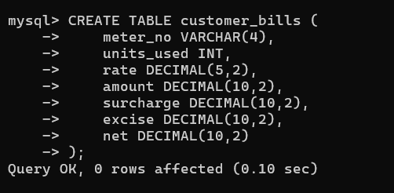

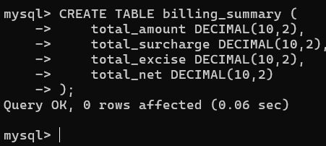

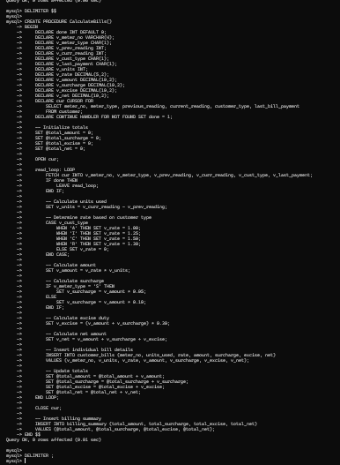

mysql> CREATE PROCEDURE CalculateBills()

-> BEGIN

-> DECLARE done INT DEFAULT 0;

-> DECLARE v_meter_no VARCHAR(4);

-> DECLARE v_meter_type CHAR(1);

-> DECLARE v_prev_reading INT;

-> DECLARE v_curr_reading INT;

-> DECLARE v_cust_type CHAR(1);

-> DECLARE v_last_payment CHAR(1);

-> DECLARE v_units INT;

-> DECLARE v_rate DECIMAL(5,2);

-> DECLARE v_amount DECIMAL(10,2);

-> DECLARE v_surcharge DECIMAL(10,2);

-> DECLARE v_excise DECIMAL(10,2);

-> DECLARE v_net DECIMAL(10,2);

-> DECLARE cur CURSOR FOR

-> SELECT meter_no, meter_type, previous_reading, current_reading, customer_type, last_bill_payment

-> FROM customer;

-> DECLARE CONTINUE HANDLER FOR NOT FOUND SET done = 1;

->

-> -- Initialize totals

-> SET @total_amount = 0;

-> SET @total_surcharge = 0;

-> SET @total_excise = 0;

-> SET @total_net = 0;

->

-> OPEN cur;

->

-> read_loop: LOOP

-> FETCH cur INTO v_meter_no, v_meter_type, v_prev_reading, v_curr_reading, v_cust_type, v_last_payment;

-> IF done THEN

-> LEAVE read_loop;

-> END IF;

->

-> -- Calculate units used

-> SET v_units = v_curr_reading - v_prev_reading;

->

-> -- Determine rate based on customer type

-> CASE v_cust_type

-> WHEN 'A' THEN SET v_rate = 1.00;

-> WHEN 'I' THEN SET v_rate = 1.25;

-> WHEN 'C' THEN SET v_rate = 1.50;

-> WHEN 'R' THEN SET v_rate = 1.30;

-> ELSE SET v_rate = 0;

-> END CASE;

->

-> -- Calculate amount

-> SET v_amount = v_rate * v_units;

->

-> -- Calculate surcharge

-> IF v_meter_type = 'S' THEN

-> SET v_surcharge = v_amount * 0.05;

-> ELSE

-> SET v_surcharge = v_amount * 0.10;

-> END IF;

->

-> -- Calculate excise duty

-> SET v_excise = (v_amount + v_surcharge) * 0.30;

->

-> -- Calculate net amount

-> SET v_net = v_amount + v_surcharge + v_excise;

->

-> -- Insert individual bill details

-> INSERT INTO customer_bills (meter_no, units_used, rate, amount, surcharge, excise, net)

-> VALUES (v_meter_no, v_units, v_rate, v_amount, v_surcharge, v_excise, v_net);

->

-> -- Update totals

-> SET @total_amount = @total_amount + v_amount;

-> SET @total_surcharge = @total_surcharge + v_surcharge;

-> SET @total_excise = @total_excise + v_excise;

-> SET @total_net = @total_net + v_net;

-> END LOOP;

->

-> CLOSE cur;

->

-> -- Insert billing summary

-> INSERT INTO billing_summary (total_amount, total_surcharge, total_excise, total_net)

-> VALUES (@total_amount, @total_surcharge, @total_excise, @total_net);

-> END $$

Query OK, 0 rows affected (0.01 sec)

